1. What is Anaconda?

* Free Software
* Provide a tool kit for doing AI Rnd

Anaconda is a popular open-source distribution of the Python and R programming languages for scientific computing, data science, and machine learning. It aims to simplify package management and deployment by providing a comprehensive ecosystem of pre-built libraries and tools. Anaconda is particularly well-known in the data science and AI communities for its ease of use and its ability to create isolated environments for different projects.

1. Key features of Anaconda in the context of AI include:
2. Package Management:

Anaconda includes the conda package manager, which simplifies the process of installing, updating, and managing software packages. It handles dependencies, ensuring that the required libraries and tools are compatible with each other.

1. Data Science and AI Libraries:

Anaconda comes with a wide range of pre-installed libraries and tools commonly used in data science and AI, such as NumPy, pandas, scikit-learn, TensorFlow, PyTorch, and Jupyter Notebooks. This makes it easy for users to get started with these tools without the need for manual installations.

1. Environment Management:

Anaconda allows users to create isolated environments for different projects. Each environment can have its own set of dependencies, avoiding conflicts between different projects that may require different library versions.

1. Cross-Platform Compatibility:

Anaconda is available for Windows, macOS, and Linux, making it a versatile choice for users across different operating systems.

1. Integrated Development Environments (IDEs):

While Anaconda can be used with various IDEs, it comes bundled with the Anaconda Navigator, which is a graphical user interface that simplifies the management of environments and packages. Users can also choose to use other popular IDEs like Jupyter, Spyder, or VSCode.

1. Conda Forge:

Conda Forge is a community-driven collection of conda packages. It provides additional packages that may not be included in the default Anaconda distribution.

1. Enterprise Solutions:

Anaconda provides solutions for enterprise users, including Anaconda Enterprise, which offers additional features such as collaboration, security, and scalability for teams working on data science and machine learning projects.

To get started with Anaconda, you can download and install it from the official website: Anaconda Download.

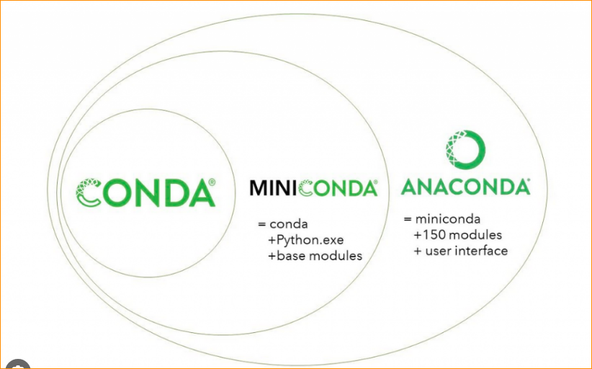

1. Anaconda, MiniConda and Conda

Mini conda- mini versions of anaconda.

Anaconda – included over 150 packages, It has user friendly navigator. User friendly

Moni conda – If you use this you have to install them. In here have to use the command lines.

Install Anaconda- <https://www.anaconda.com/download>

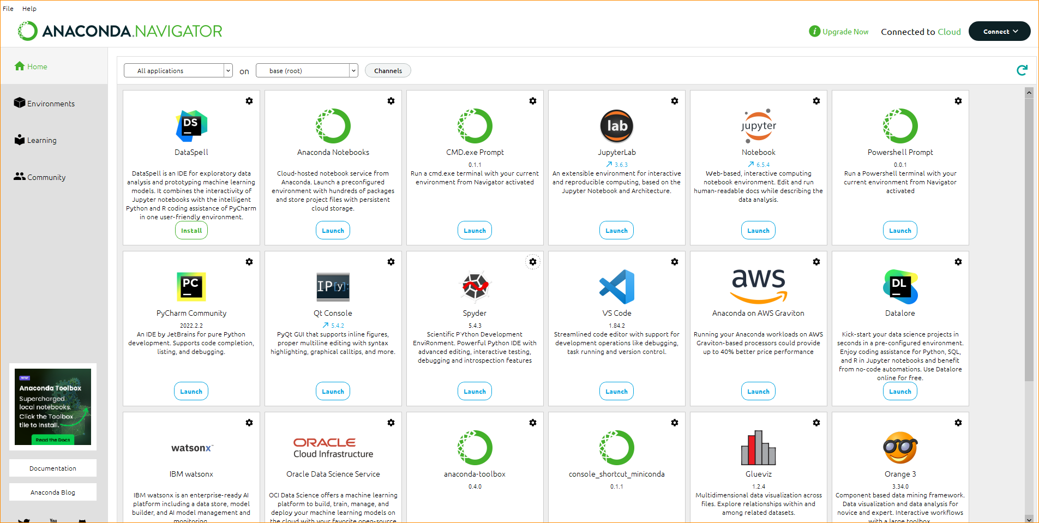

1. **JupyterLab**

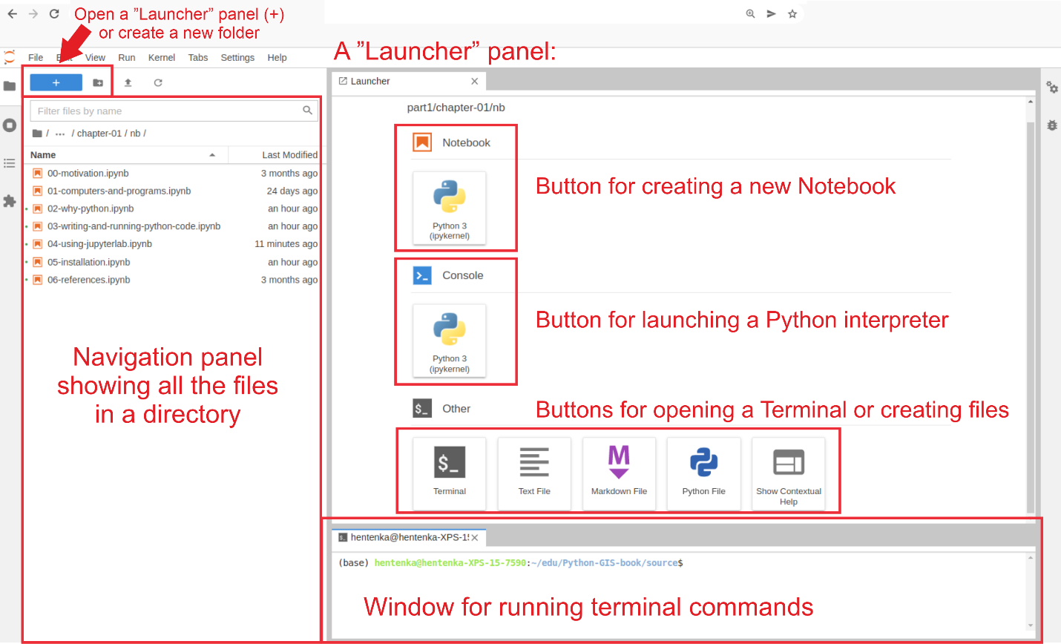

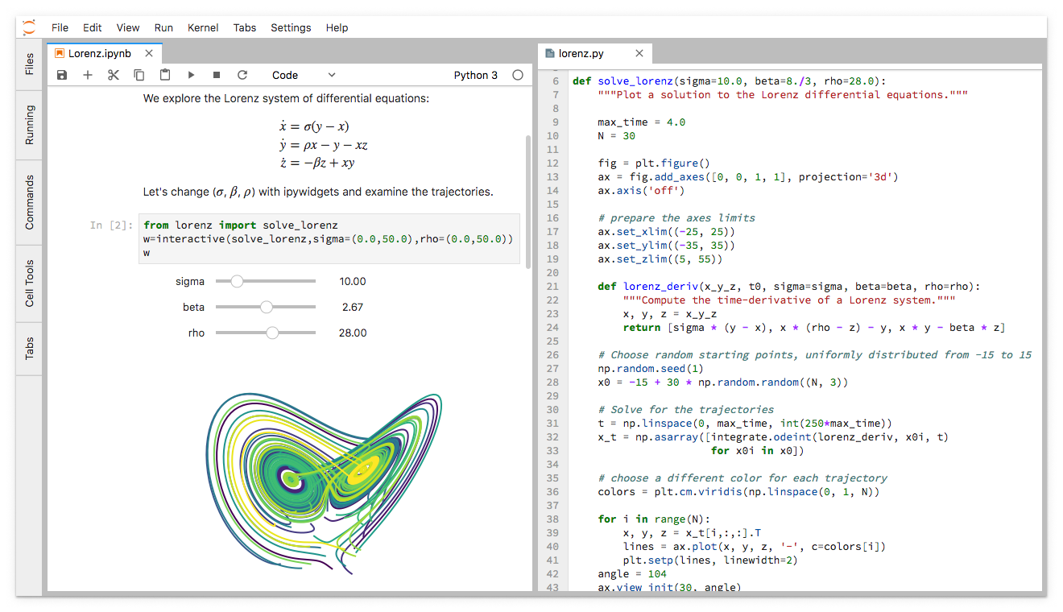

**JupyterLab** is an open-source web-based interactive development environment (IDE) for working with Jupyter notebooks, code, and data. It provides a flexible and extensible architecture that supports a variety of workflows in scientific computing, data science, and machine learning.

**Key features of JupyterLab include:**

* **Notebook Interface**: JupyterLab retains the familiar notebook interface, which allows users to create and share documents that contain live code, equations, visualizations, and narrative text.
* **Multiple Document Interface (MDI):** JupyterLab extends the capabilities of the classic Jupyter notebooks by introducing a tab-based interface that allows users to work with multiple documents (notebooks, code files, etc.) simultaneously.
* **Interactive Computing:** JupyterLab supports interactive computing in multiple languages, including Python, Julia, R, and others. It enables users to run code cells, visualize results, and iterate on their analyses in real-time.
* **File Browser:** Users can navigate and manage their files within JupyterLab using a file browser. This makes it easy to organize and access data files, code scripts, and other resources.
* **Extensions:** JupyterLab is highly extensible, allowing users to customize and enhance their environment with various extensions. These extensions can add new features, integrate with other tools, or provide additional functionality.
* **Integration with Version Control:** JupyterLab has built-in support for version control systems like Git, allowing users to track changes to their code and collaborate with others more effectively.
* **Rich Output:** JupyterLab provides rich output capabilities, supporting interactive visualizations, plots, images, and other media directly within the notebook interface.

1. **JupyterLab**

JupyterLab has become a popular choice among data scientists, researchers, and educators for its versatility and user-friendly interface. It serves as a powerful tool for developing, testing, and sharing code and analyses in various domains.

Jupyter Notebook is an open-source web application that allows you to create and share documents that contain live code, equations, visualizations, and narrative text. It is widely used in the fields of data science, scientific research, machine learning, and education. The name "Jupyter" is a combination of the three core programming languages it supports: Julia, Python, and R.

Here are some key features and characteristics of Jupyter Notebooks:

* Interactive Computing: Jupyter Notebooks support interactive computing by allowing users to write and execute code in a step-by-step manner. Code is organized into cells, and each cell can be executed independently.
* Multiple Language Support: While initially designed to support Julia, Python, and R (hence the name Jupyter), the notebook has been extended to support many other languages, including but not limited to, Java, C++, and Scala.
* Markdown Support: In addition to code cells, Jupyter Notebooks support Markdown cells, which allow users to write formatted text, include images, and create rich documentation alongside the code.
* Visualization: Jupyter Notebooks provide excellent support for visualizing data. Users can generate plots, charts, and other visualizations directly within the notebook using libraries like Matplotlib, Seaborn, and Plotly.
* Export and Sharing: Notebooks can be easily exported to different formats, such as HTML, PDF, or slideshows. This makes it convenient to share analyses and reports with others. Notebooks can also be shared on platforms like GitHub or Jupyter's own hosting service, nbviewer.
* Education: Jupyter Notebooks are widely used in educational settings for teaching programming and data science. They provide an interactive and approachable way for students to learn and experiment with code.
* Kernel Architecture: The code in a Jupyter Notebook is executed by a kernel, which is a computational engine that runs the code. Different kernels can be used for different programming languages, allowing for polyglot programming within a single notebook.
* Integration with Libraries: Jupyter Notebooks integrate well with a variety of libraries and frameworks commonly used in data science and scientific computing, such as NumPy, Pandas, SciPy, and scikit-learn.

To use Jupyter Notebooks, you typically install Jupyter on your machine and then launch the Jupyter Notebook server. This opens a web-based interface where you can create, edit, and run notebooks in your browser. The interactivity and ease of sharing make Jupyter Notebooks a powerful tool for data analysis and exploration.

1. **Spyder**

Spyder is an open-source integrated development environment (IDE) designed for scientific computing, data analysis, and machine learning in Python. It provides a comprehensive set of tools for interactive development and exploration of Python code. Spyder is part of the Anaconda distribution, a popular platform for data science and scientific computing in Python.

Key features of Spyder include:

* Editor: Spyder includes a powerful code editor with features like syntax highlighting, code folding, and integrated IPython consoles. The editor supports multiple tabs, making it easy to work on and switch between multiple files.
* Interactive Console: Spyder integrates IPython consoles that allow for interactive execution of Python code. This is particularly useful for exploring data, running experiments, and quickly testing code snippets.
* Variable Explorer: The Variable Explorer provides a graphical interface to inspect and manipulate variables in your code. It displays the current state of variables, data frames, and arrays, making it easy to understand and debug your code.
* Integrated Help: Spyder offers integrated help and documentation, providing quick access to information about Python functions, modules, and libraries. This can be useful for learning about new functions or understanding how to use specific modules.
* Plotting: Spyder includes a built-in interactive plotting system, which allows users to create and visualize plots directly within the IDE. This is powered by the Matplotlib library and provides a convenient way to explore and analyze data.
* Debugger: Spyder comes with a debugger that allows users to set breakpoints, step through code, and inspect variables during runtime. This is essential for debugging and understanding the flow of complex programs.
* Variable Explorer: The Variable Explorer is a feature that provides a graphical interface to view, edit, and interact with the variables in your code. It's particularly useful for data analysis tasks, as you can inspect and manipulate data frames and arrays easily.
* Integration with Conda: Spyder integrates seamlessly with the Conda package manager, which is commonly used in the Python ecosystem for managing dependencies and virtual environments. This makes it easy to create and manage Python environments for different projects.

Spyder is well-suited for scientists, engineers, and data scientists who work with Python for numerical and scientific computing. Its features cater to the needs of those who perform data analysis, develop machine learning models, and conduct scientific research using Python.

